AM420 – Aerodynamics
Forces on an Airfoil

(Revised by G. Dewar for ELD Wind Tunnel - Oct. 2000)

- Introduction

The forces on a body moving through a fluid are the result of the pressure and shear stress distributions over the surface of the body. The resultant force can then be resolved into the lift and drag components. The purpose of this laboratory is to use a load cell to measure the aerodynamic forces on two NACA airfoils. These measurements can then be compared to simulation results.

- Laboratory Information

The purpose of this lab is to measure the forces on two NACA airfoils over a range of angles of attack and use this data to study the lift, drag and moment characteristics of each airfoil.

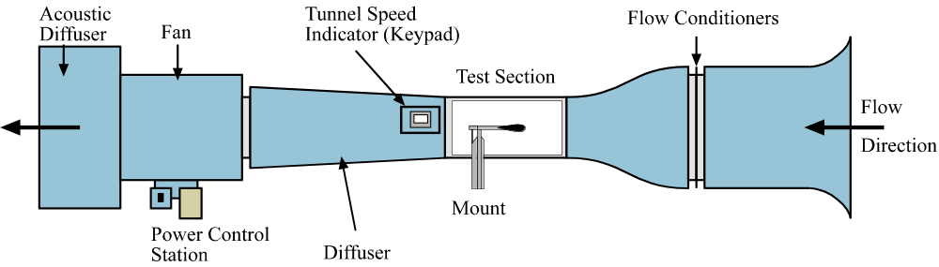

Figure 1: Low Speed Wind Tunnel.

The Low Speed Wind Tunnel (figure 1) is used to carry out the experiment. A 6-inch chord length NACA0012 or NACA4412 airfoil can be mounted on a load cell mount in the center of the tunnels 18-inch by 18-inch test section. The angle of attack can be controlled by adjusting the mount below the tunnel test section.
The forces applied to the airfoil are sensed as voltages by load cell sensors within the arm of the mount (figure 2) and read by digital multimeters, with these voltages being sent to the PC for analysis. The LabVIEW program used to carry out the experiment converts the voltages to forces and moments, with the outputs from the program giving the Axial Force, A, and Moments M1 and M2 around the center of the load cell. The airfoil can be fitted to the mount arm and held in place by two set screws.

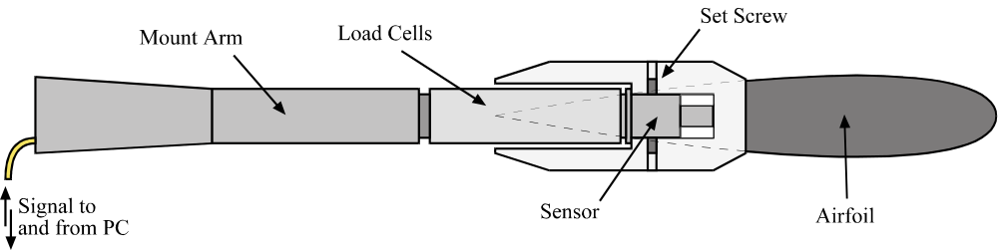

Figure 2: Mount Arm with Load Cell.

The velocity within the tunnel test section is controlled by the PC. A Pitot-Static probe is placed in the entrance to the test section to measure the velocity, with the measured value being sent from the pressure transducer to the PC. The instrumentation for the tunnel can be seen in figure 3. The computer sets the speed of the tunnel from the Reynolds number the user inputs at the start of the program, as described in part 4 of this report. The required Reynolds number will be given by the Teaching Fellow.

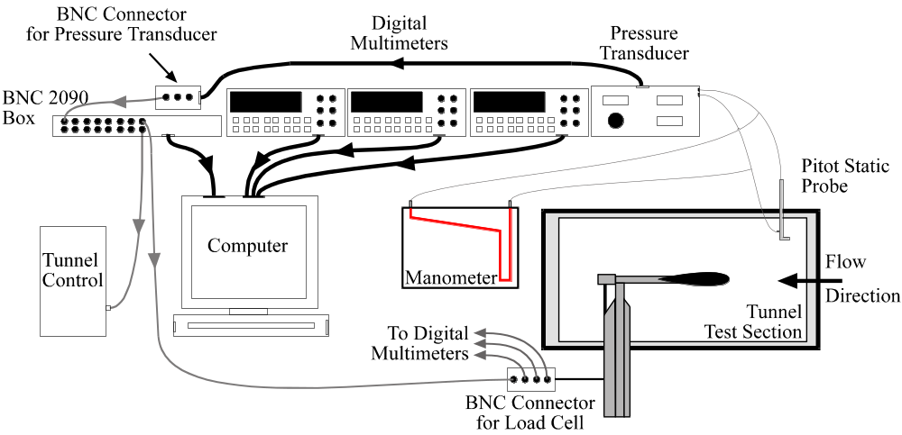

Figure 3: Experimental Setup for Tunnel Test Section

For this lab, measurements will be taken for both positive and negative angles of attack at two degree increments up to a maximum of 16⁰. Thus, for a single run of the experiment data will be obtained at 0⁰, 2⁰,…, 14⁰, 16⁰, 14⁰,…, 2⁰, 0⁰. This procedure will be repeated for negative angles of attack and for each airfoil.

- Theory

The freestream velocity can be calculated from the differential pressure 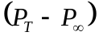, where 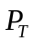 is the total pressure measured by the Pitot-probe, and 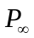 is the static pressure measured from the static tap. The freestream velocity, 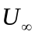, can then be found from Bernoulli’s equation;

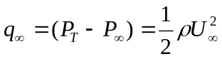 (1)

The corresponding Reynolds number can then be found;

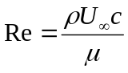 (2)

where c is the chord length of the airfoil.
Defining the resultant force along the direction of the chord as A and the resultant force normal to the chord as N, the lift and drag on an airfoil can be defined as:

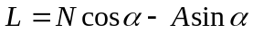 (3)
and
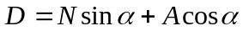 (4)

where the lift, L, is defined as the resultant force normal to the freestream velocity and the drag, D, is the resultant force in the direction of the freestream velocity. The angle of attack, α, is defined as the angle between the chord and the freestream velocity (see figure 4).

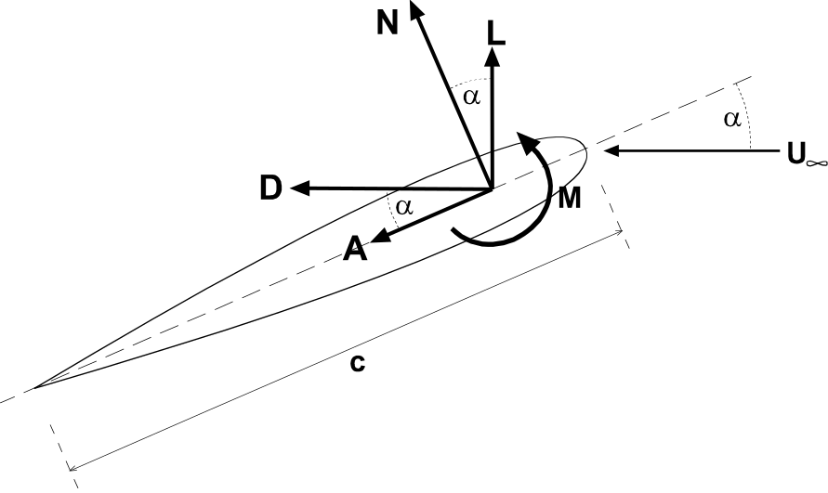

Figure 4: Resultant aerodynamic forces on airfoil.

The coefficients of lift and drag can then be calculated using:

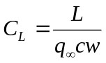 (5)
and,
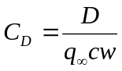 (6)

where ‘w’ is the width of the airfoil.
The Load Cell has three internal sensors, one which measures the axial force, A, and two moment sensors, M₁ and M₂, which measure the moment about the center of the Load Cell. The moment sensors are located a distance x=0.06533m apart (i.e. each sensor is 0.03266m from the center of the load cell), as can be seen in figure 5. The leading edge of the airfoil is a distance d_{L.E.}=0.1397m from the center of the Load Cell.

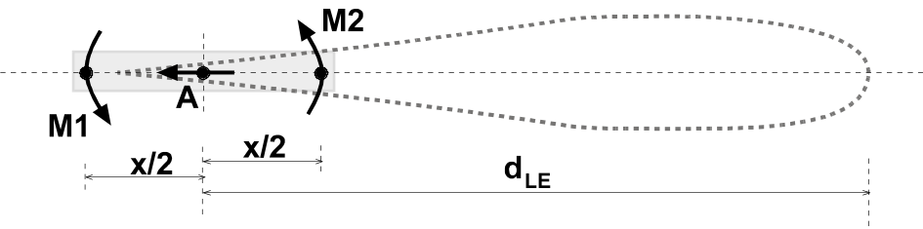

Figure 5: Geometry for Load Cell Sensors.

The load cell measures the total force and moment acting on the airfoil, which comprises of the aerodynamic forces and the forces and moments due to the mass of the airfoil. Therefore, to obtain the aerodynamic forces it is nessessary to subtract the effect of the airfoil mass on the values obtained from the load cell. The mass and location of the center of mass (with respect to the center of the load cell) for each airfoil are:

NACA0012 Mass = 1.278 kg
Center of Mass = 0.0733 m
NACA4412 Mass = 1.2654 kg
Center of Mass = 0.0739 m

The resultant normal force on the airfoil, N, and the distance, d_{N}, from the Load Cell center at which it acts can be found from the relationship between the two moments M₁ and M₂, and can be calculated from the following equations:

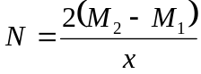 (7)

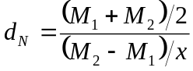 (8)

Having found the normal force, N, and the location at which it acts, d_{N}, the moment at any point on the airfoil can then be found from the equation:

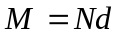 (9)

where d is the distance from the position d_{N} to the point at which you want to calculate the moment. Note: the moment is positive when it is directed anti-clockwise around the location of interest.

The corresponding coefficient of moment is then:

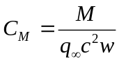 (10)

- Experimental Procedure

For this lab, the TF will have carried out the transducer and load cell calibrations before the lab begins.

WARNING: Be extremely careful when handling airfoils! Do not remove or insert an airfoil unless the TF is present. Do not overtighten set screws.

- Attach airfoil to load cell mount.

- Level load cell mount in center of tunnel.

- Close tunnel.

- Make sure the pressure transducer assembly and digital multimeters are powered.

- Make sure Pressure Selector on Digital Readout Assembly is set to port '0'. (Note: this gives the Pitot Probe reading)

- Open LabVIEW program ‘Airfoil(force)’ from the Am420\Lab 3 folder.

- Input required information into 'INPUTS' panel.

- Make sure TF has input Calibration data for pressure transducer, tunnel speed indicator and load cells.

- Left click 'Play' button (top left of screen) to start program.

- Left click on ‘CONTINUE’ button to turn tunnel on.

- Wait until tunnel has reached steady state (i.e. the output frequency reading on the Tunnel Speed Indicator is constant).

WARNING: Failure to wait until the tunnel has reached steady state will result in an error in the speed setting!

- Left click on ‘SET SPEED' button to set tunnel to speed corresponding to required Reynolds number.

- Wait until tunnel has again reached steady state.

- Set the airfoil to the required angle of attack using the appropriate spacer.

- Left click on the ‘TAKE READING’ to read the forces from the digital multimeters.

- Repeat steps xiv and xv for each required angle of attack.

- On completion of the program the tunnel will turn off automatically.

- Output data (angle of attack, axial force, M1, M2) will be sent to the file indicated in the ‘OUTPUTS’ panel.

- Record the indicated velocity in the tunnel from the ‘OUTPUTS’ panel.

- Repeat this procedure for the negative angles of attack and for each airfoil.

- Required Calculations & Analysis

- For each airfoil calculate L, D and the moment about the quarter chord, M_{1/4chord}. In order to find L, you need to first find N from equation (7). Then the effect of the mass of the airfoil needs to be taken in consideration. In order to account for this effect you need to add to this value of N the component of the mass of the airfoil in the direction of N. In other words a proper relationship between N, M1, M2 and the mass of the airfoil is a modified eq. (7):
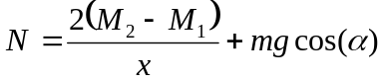

In case with drag, it is very difficult to predict the correct effect of the mass of the airfoil
on D because of the complicated interaction between the airfoil and the load cell, which
seems to effect the measurements of the force in the direction of D. Therefore, do not
correct the values of drag for the effect of the mass of the airfoil. Simply calculate drag
from eq. (4), using the corrected value of N and the original value of A. If a suitable
correction factor for drag is later determined, you will be provided with it by your TF.
- For each airfoil, calculate C_{L}, C_{D}, C_{M(l.e)} and C_{M(1/4chord)}.

- For each airfoil, tabulate α, velocity, N, A, L, D, M_{l.e}, M_{1/4chord}, C_{L}, C_{D}, C_{M(l.e)} and C_{M(1/4chord)}.

- On a single graph, plot α against C_{L} for each airfoil. Compare to simulation data.

- On a single graph, plot α against C_{D} for each airfoil. Compare to simulation data.

- On a single graph, plot α against M_{l.e} for each airfoil.

- On a single graph, plot α against M_{1/4chord} for each airfoil. Compare to simulation data.

- Tabulate the stall angles for each airfoil. Comment on stall and reattachment properties of each airfoil.

- Laboratory Report Format

The purpose of this lab is not only to apply your understanding of aerodynamics to a simple experiment but also to give you practice in communicating your findings. As such, the quality of the writing will be evaluated in terms of grammar, spelling, clarity, organization, and legibility and legibility of figures and tables. The report should be understandable by someone who is not necessarily familiar with the specifics of the lab. The quality of the writing will count for a portion of your grade.
Reports must be typed, double-spaced with suitable margins. Please use only one side of the page, normal white paper; forgo fancy covers. The following format is required for the organization of the report:

- Title page
- Introduction
- Theory and Methods
- Results and Analysis
- Discussion and Conclusions
- Appendices (e.g. data, sample calculations)

The Title page should include the title of the lab, the names of all members of the lab group, as well as the date on which the lab was performed. Please make this a separate page.
The Introduction section should briefly state in your own words what you are trying to do and why you are doing the experiment. Do not simply copy or paraphrase the appropriate sections of the lab handout.
The section on Theory and Methods should explain the relevant theory, measurement techniques, and procedures for the lab. Please be complete and sufficiently detailed so that someone who has not performed the lab can understand your report. Derivations of equations used in your analysis are appropriate. Again, do not simply copy or paraphrase the appropriate sections of the lab handout.
In the Results and Analysis section, you should summarize and explain the results of the experiment, including charts and graphs. Graphs should be plotted to best show the information gained from the experiments, i.e. use linear or log scaling where appropriate, plot experimental data as individual points and theoretical data and computational data as continuous lines, and make sure all axes and data curves are clearly labeled. This section should be strictly factual, pointing out agreement and discrepancies between your results and those predicted by theory. All numerical results should be non-dimensional or reported in SI units. This is where most of the items you calculate and plot in the ‘Required Calculations and Analysis’ section should go.
For the Discussion and Conclusions, examine whether the lab satisfies the stated purpose, explaining what you have learned. Also postulate why any differences might have arisen between the theoretical (or standard experimental) values and your own results.
The Appendices should contain relevant information that is not in the body of the lab report, such as the original data sheets and details of calculations made both in lab and as part of your data analysis. Sample calculations should either be typeset or neatly written in ink.
If you rely on information from textbooks or other references, cite the references in appropriate bibliographical style. Quoting references without citing sources is plagiarism.

